British Postal Museum
Railway related postcards as at February 2015

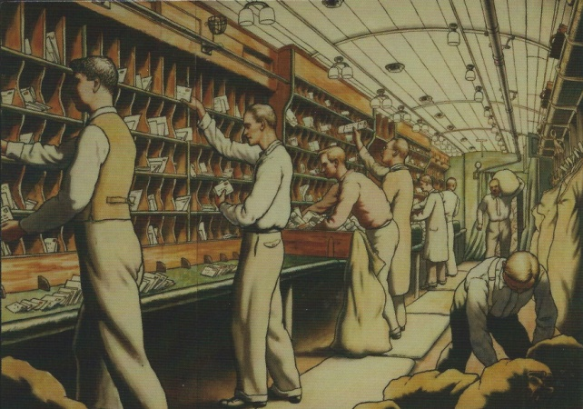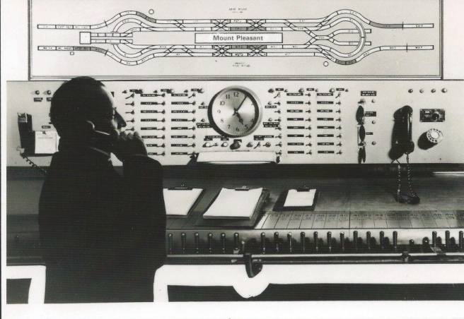
Post 109/375 BPMA PC 14d Interior of TPO 1935 Post 118/5787 BPMA PC 14e Switch frame 1971
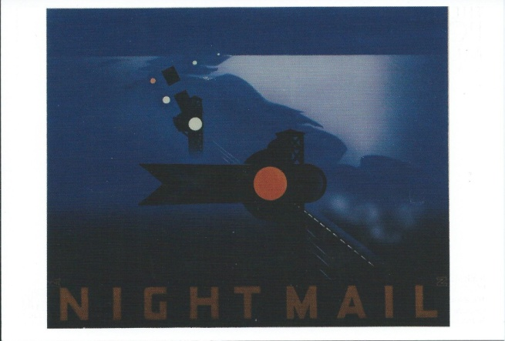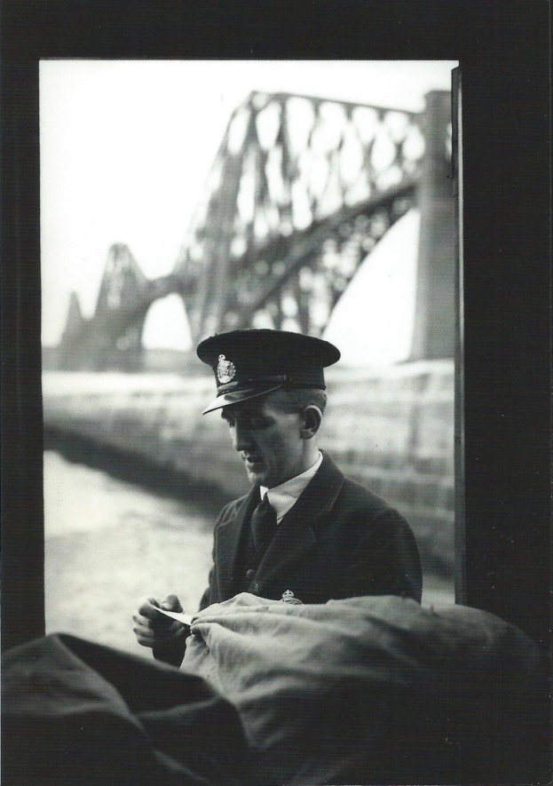
Post 109/377 BPMA PC 14b Night Mail 1939 Post 118/96 BPMA PC 15c Forth Bridge 1934

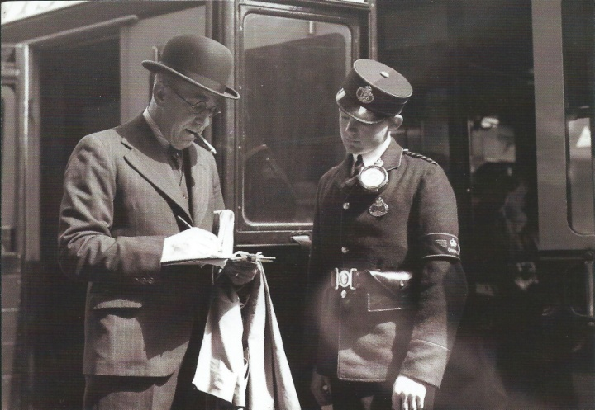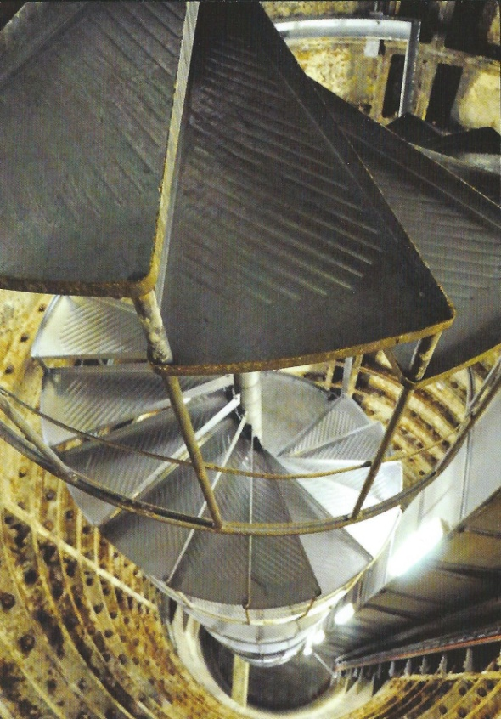
Post 118/69 BPMA PC 17d Paddington Station 1936 BPMA PC 20b PO underground railway ascent 2013
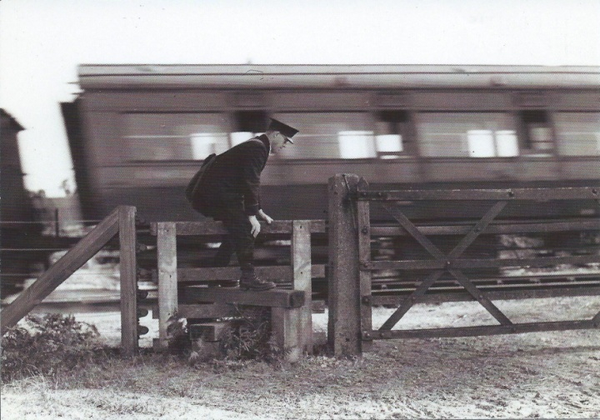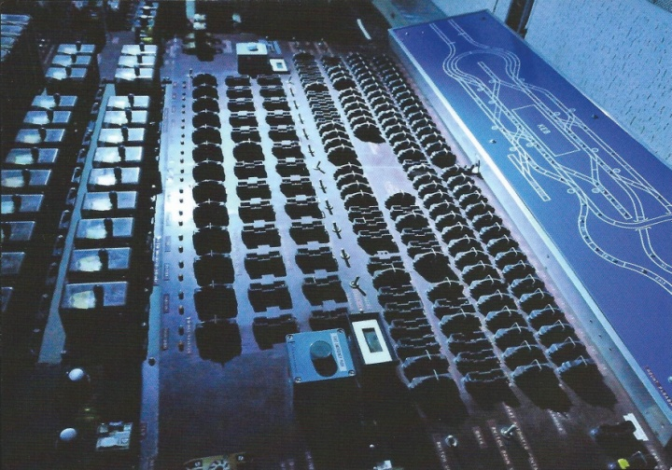
Post 118/1856 BPMA PC 19f Norfolk 1947 BPMA PC 20d relay board 2013

