Lavender Line, Isfield, Sussex
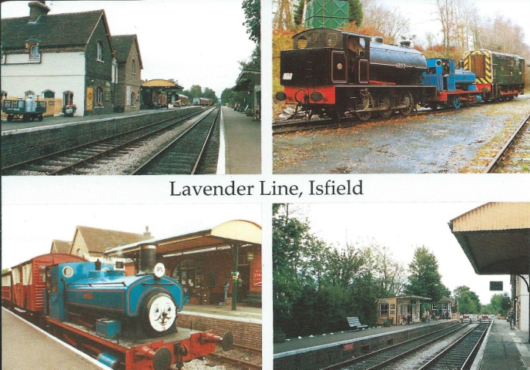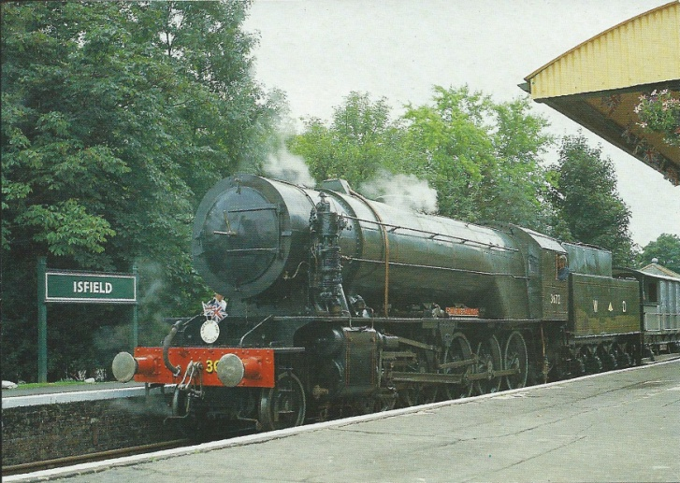
Judges of Hastings C14500X Judges Postcards Ltd 3672 Dame Vera Lynn C8858X

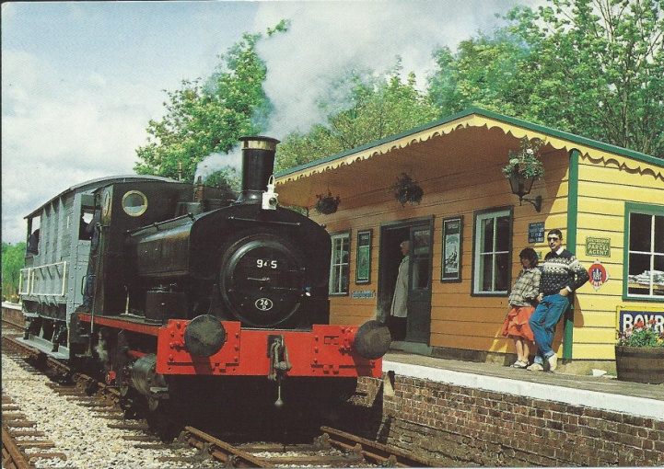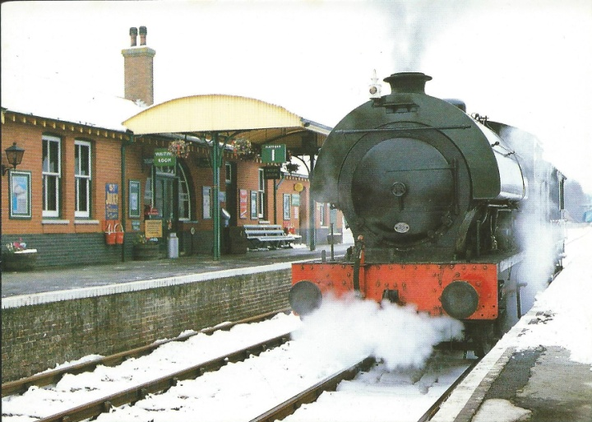
Judges Postcards Ltd Andrew Barclays 945 C7931X Beric Tempest Stevenson Hawthorne No.62

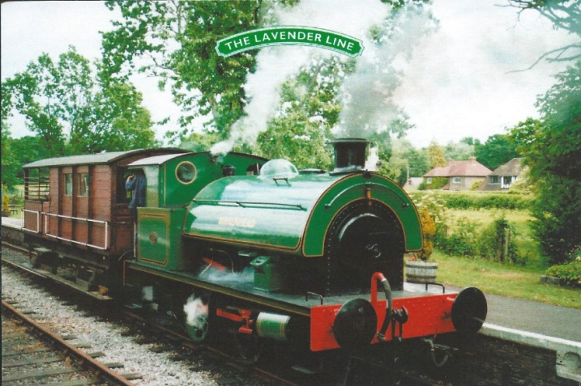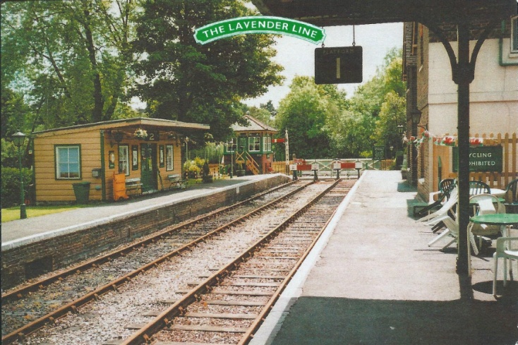
Smartart Birkenhead Smartart Isfield station
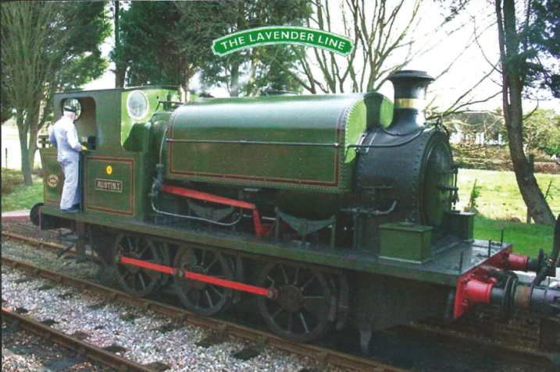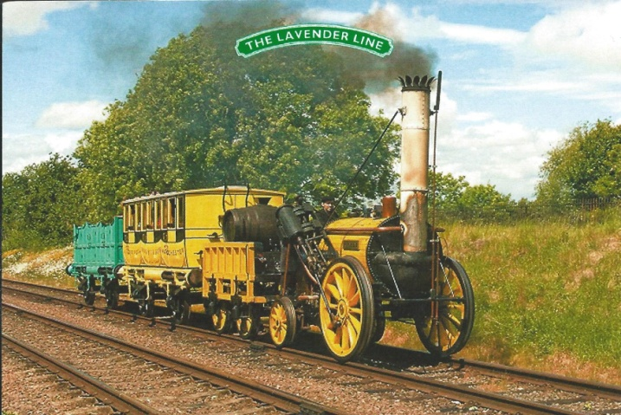
Smartart Kitson Austin 1 Smartart replica Rocket

