Tiverton Museum, Devon

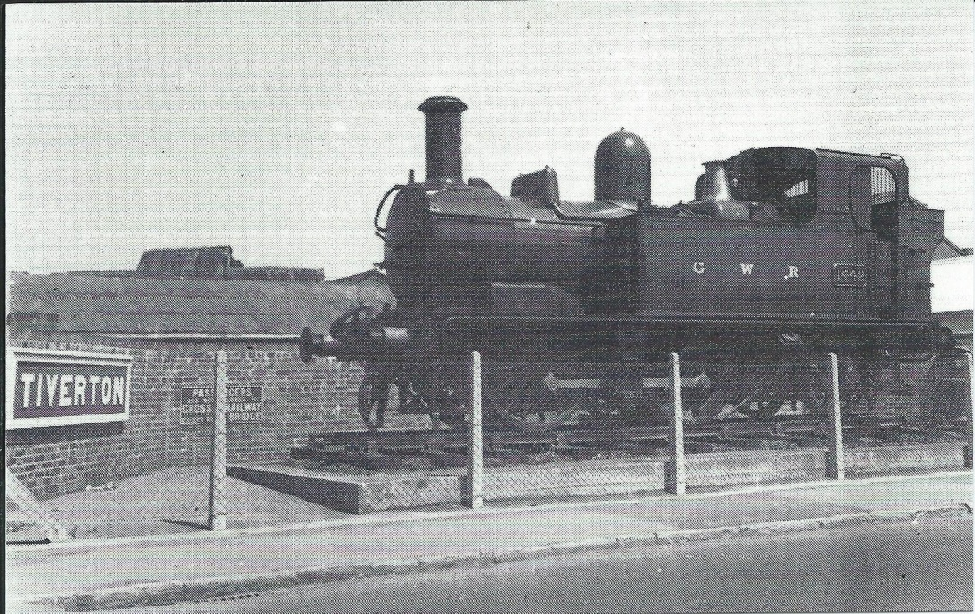
Black and white postcard at least two printings – see below
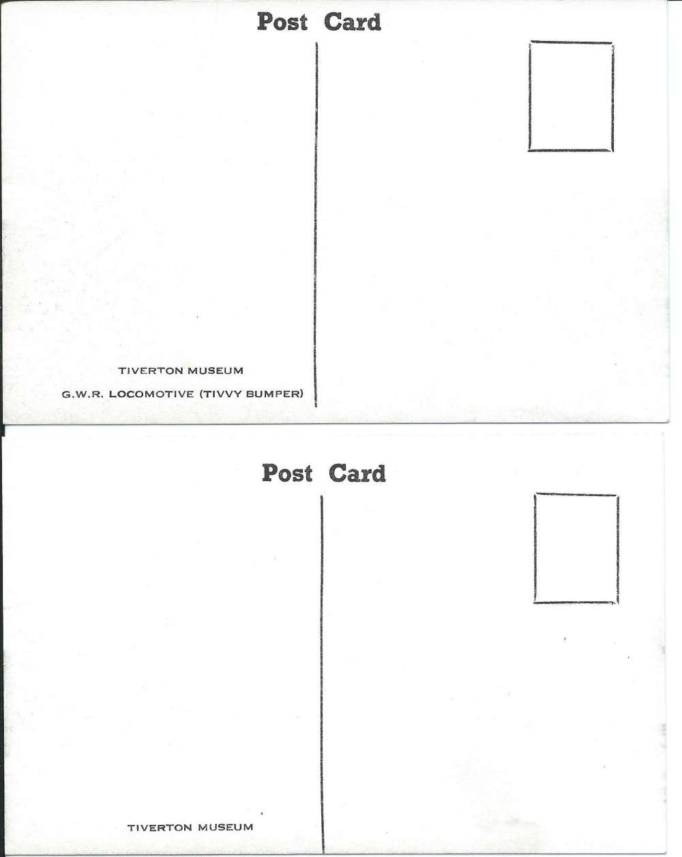
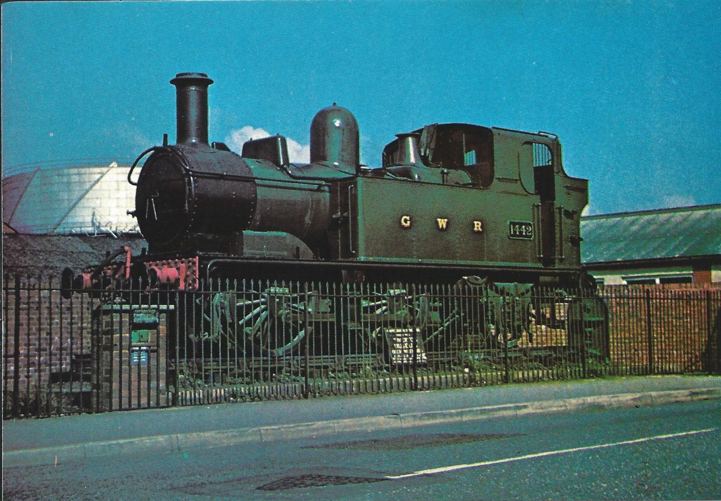
Tiverton Museum Tivvy bumper
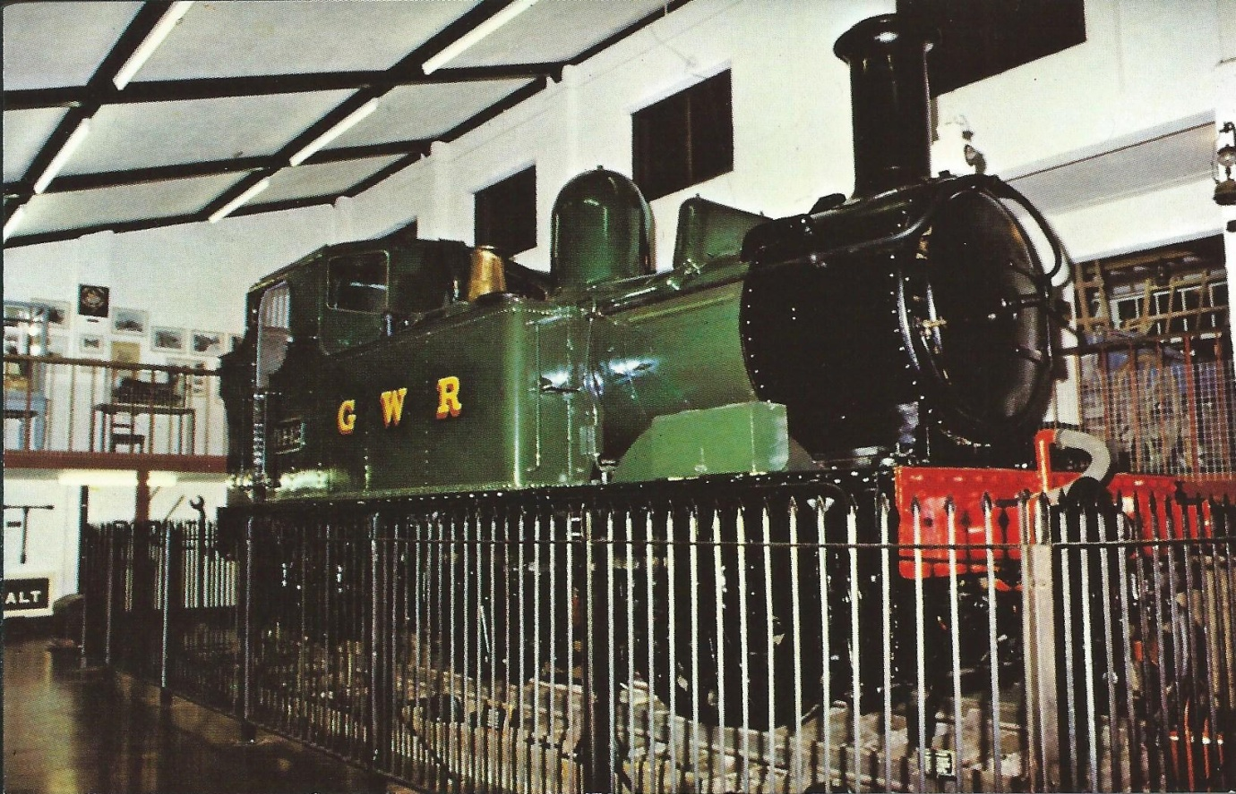

Smaller card published by Dennis and larger size reprint by Unichrome
Tiverton museum, the largest social history museum in the south west.

