National Postal Museum – Railway Sponsorship Postcards
In return for sponsoring a sleeper on the soon to be re-opened Post Office railway system, as well as a line walk and train trip you receive a certificate and a set of postcards. The four images are:

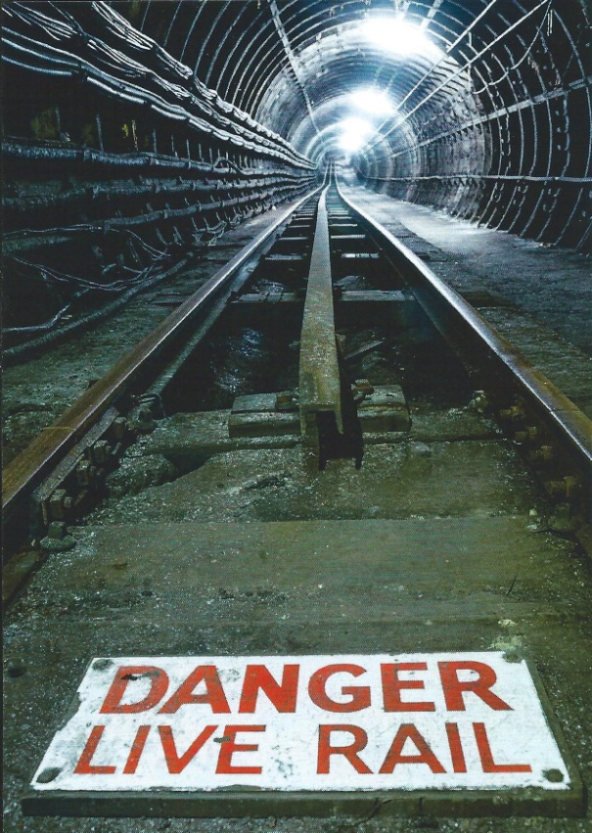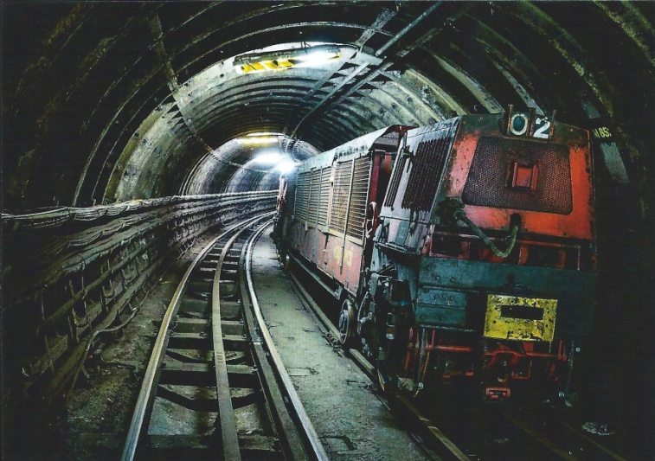
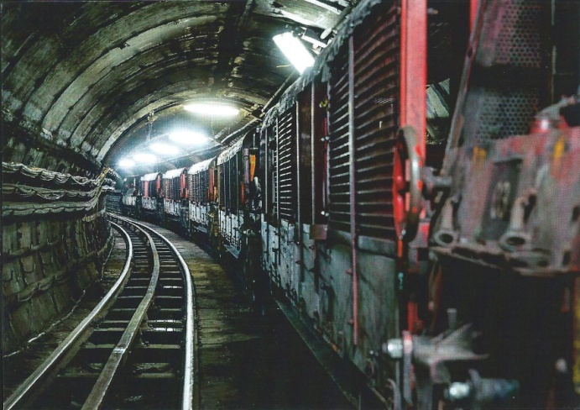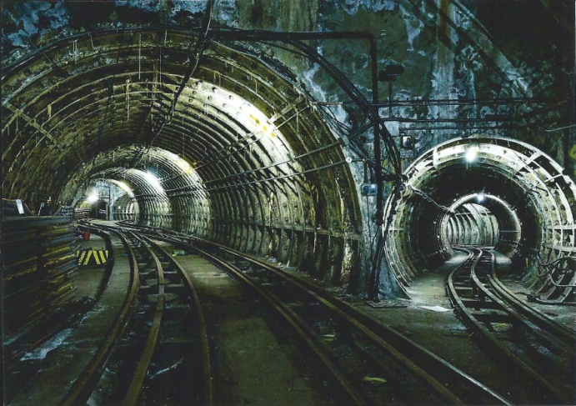
Full details from www.postalmuseum.org
The sleeper sponsorship costs £250.

